***Our Goals for Student Achievement***

***District Academic Goal***

Academic Program…

Our students will be well-rounded individuals who possess the necessary academic skills and knowledge and are excited about learning.

**Math – K-5:**

By the end of the 2015-2016 school year, increase by 5% the number of students who score at the meets or exceeds level on the mathematics portion of the state standardized test. By the end of the 2015-2016 school year, decrease the achievement gap by at least 10 points in grades 3 – 5.

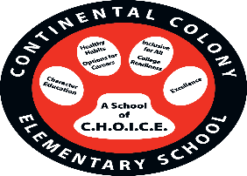

***Continental Colony School Goals***

***Focus Area: Math***

Increase a math fluency and application of complex mathematical problem –solving in grades K-5

**Continental Colony Classroom**

***Continental Colony*** will work with students and their families to support students’ success in all content areas. Some of our key connections with families will be:

* Helping students to fluently add and subtract mentally and orally by 5.
* Differentiated instructional math time in the classrooms to meet the needs of student.
* Helping students to develop an understanding of addition, subtraction, and strategies for addition and subtraction by 20.
* Assisting students in understanding of base-ten notation.
* Helping students to develop an~~d~~ understanding and fluency with multi-digit multiplication.
* Assisting students with developing an understanding of dividing to find quotient~~s~~ dividends.
* Helping students to develop fluency with addition and subtraction of fractions.
* Assisting students with solving word problems using addition, subtraction, multiplication and division.

**Continental Colony Family**

***Continental Colony*** parents/guardians have been invited to develop ideas about how families can support students’ success in all content areas. Families may have other ideas to add to this list:

* I will help my child practice addition and subtraction with fraction.
* I will have a Family Math Night at home with math manipulatives from Math Fluency workshops.
* I will help with math fluency with multi-digit multiplication.
* I will attend Math-o-ween Night to learn more math tips and strategies.
* I will help my child practice addition, subtraction, multiplication, and division facts.

***Continental Colony School Students***

***Continental Colony*** students joined with staff and parents to develop ideas about how they can succeed in school and reach for goals in all content areas. Students thought of the following ideas to make connections between learning at home and school:

* I will practice addition, subtraction, multiplication, division by 20.
* I will memorize multiplication and division facts. *How are you doing this?*
* I will practice base-ten notation at home by…
* I will practice solving word problems by…

**Building Parent Partnerships**

***Continental Colony*** is committed to frequent two-way communication with families about students’ learning. Some of the ways you can expect us to reach you are:

* Bi-weekly update to Parent Portal
* Updates on the school and class websites, social media and more
* Weekly e-blasts to all families regarding learning objectives, important announcements, and upcoming events.
* Parent-Teacher conferences

***Communication about Student Academic Learning and Achievement***

***Open House –August 3, 2015***

***Annual Title I Meeting- August 18, 2015***

***Curriculum Night-August 18, 2015***

***PIP/School-Parent Compact Meeting-August 22, 2015***

***Parent University- Monthly***

***Principal’s Chat- 1st Friday of the month***

***Parent-Teacher Conference- Sept 16, 2015 & Mar 2016***

***Reading Boot Camp Pt. 1 & 2- Sept. 11, 2015 & Feb. 19, 2016***

***Math Fluency Pt. 1& 2- Oct. 16, 2015 & Jan. 29, 2016***

***Diving Into Technology (Math & Reading) - Nov. 13, 2015 & Mar.11, 2016***

***What is a compact?***

A compact is a written agreement of how school staff, students and parents will work together to help students achieve. Each school that receives Title I money must have a compact. 

***What is the purpose of a compact?***

The purpose of a compact is to list the specific duties of school staff, students, and parents in student learning. With a compact, everybody knows what everyone is to do. The compact also includes how the school, staff, and parents will communicate with each other.

* Focus on student learning
* High-quality instruction
* Link school goals
* Share strategies for parents to use at home

The principal and staff will make sure that the school is safe and secure so that students can focus on learning, free of disturbance and fear.

Teachers, Parents and Student– Together for Success!

Continental Colony staff, families and students developed this School-Parent Compact jointly for Student Achievement. Meeting are held each year to review the Compact and make changes based on the student’s needs.

**All parents/guardians are welcome to contribute comments and/or suggestions at any time. Title I Planning Meeting are open to ALL parents/guardians.**

**questions About Parental Involvement can be directed to the Title I Parent Liaison, SONYA WILLIAMS, in the Parent center (404)802-8022**

**Parent Center Hours:**

**9:00am-2:00pm**

**rOOM 1032**

**Continental Colony ELEMENTARY SCHOOL**

3181 Hogan Rd, SW

Atlanta, GA 30331

Phone: (404) 802-8000

Webpage:

<http://www.atlanta.k12.ga.us/Domain/457>

***Continental Colony Elementary School***

***School-Parent Compact for Achievement***

***2015-2016***

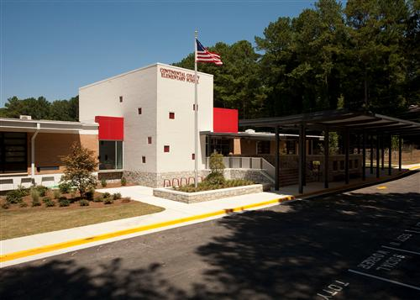

***Mr. Frederico L. Rowe, Principal***

***Our Mission:***

***Continental Colony Staff, Students, Parents, and Partners will work together as one to enhance learning opportunities that yield life long benfits. We share a commitment and an expectation of academic rigor, respect, and innovative approaches to excellence.***

***Revised: September 24, 2015***